
- December, 2003

Building, Searching, Linking and Using Learning Objects
A Success Story - The Wisconsin Online Resource Center Repository

Kay Chitwood, Fox Valley Technical College

The Wisconsin Online Resource Center, called Wisc-Online, is a repository of more than 1,000 learning objects. Learning objects are defined in a variety of ways. The center defines learning objects as follows: (1) small, independent chunks of knowledge or interaction stored in a database; (2) based on a clear instructional strategy; (3) self-contained in that each learning object can be taken independently; (4) may be interactive in that students view, listen, respond, or interact with the content in some way; (5) reusable in that a single learning object may be used in multiple contexts; and (6) built to meet the quality standards of the Wisconsin Online Resource Center.
Wisc-Online was created to house digital, Web-based, multi-media learning objects that are authored by faculty and technically developed by Web programmers. Wisc-Online provides a place for faculty members to search, locate, and link learning objects into their instructional deliveries, no matter what the delivery format – face-to-face, online, supplementary, presentation, or lecture. Learning objects have been created in a number of areas including general education, adult basic education, manufacturing, health, business, service, and professional development.
Students report they like the learning objects that visually present a concept through animations or interactions they can manipulate. Students can not only view the learning objects as many times as they wish, but they are able to access them anywhere or anytime.
The learning object entitled, Application Success, provides tips on the kinds of information usually requested on an application form. As one learns about the process of completing an application, the user adds his/her own personal information.
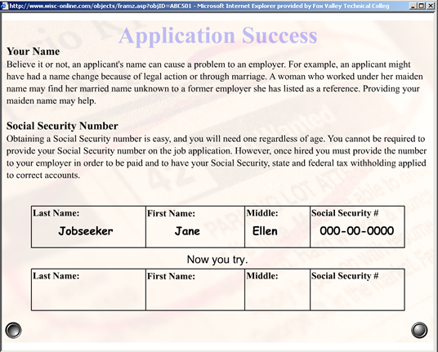 | Application Success  Author: Laurie Jarvis  School: Fox Valley Technical College  Description: Students read tips for filling out a job application and complete an online application form.
The best way to understand the power of learning objects is to experience them. Visit Wisc-Online Resource Center at http://www.wisconline.org to review more than one thousand fifty learning objects currently available online.

